1. What is homogenous coordinate system? Explain its use? (4)

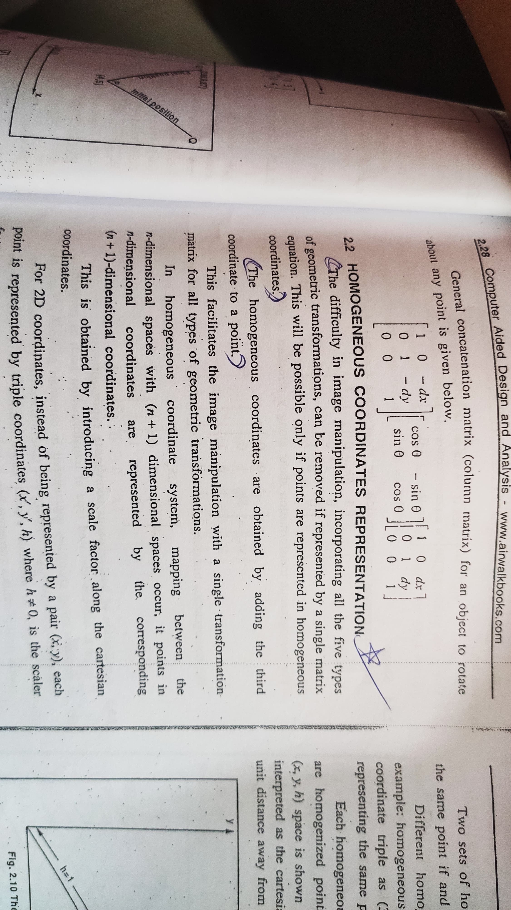

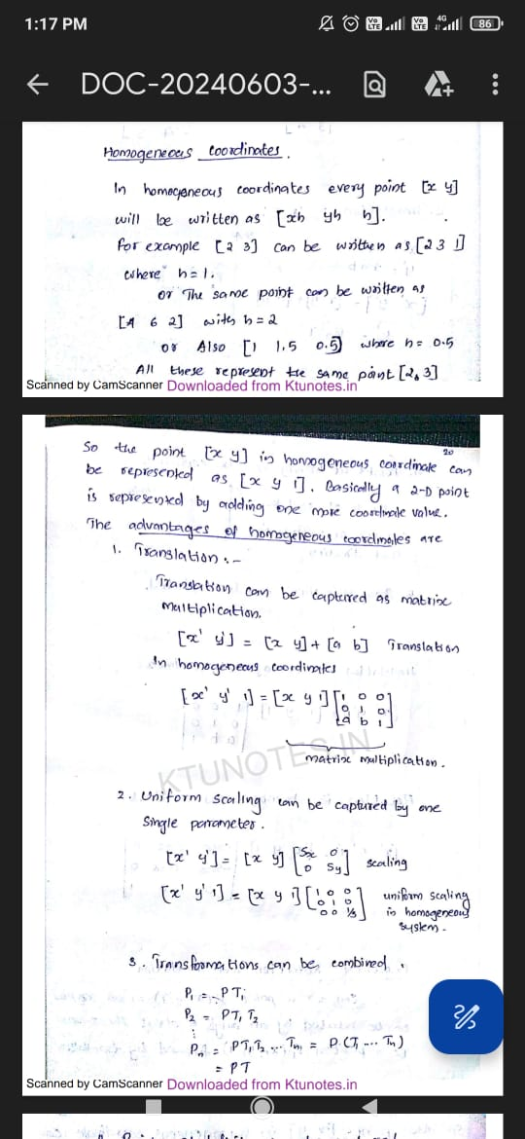

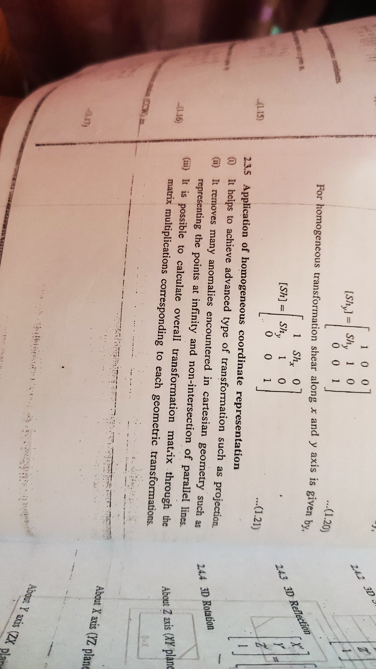

1. Write the transformation matrices for rotation about x,y,z axis in homogenous coordinates? (6)

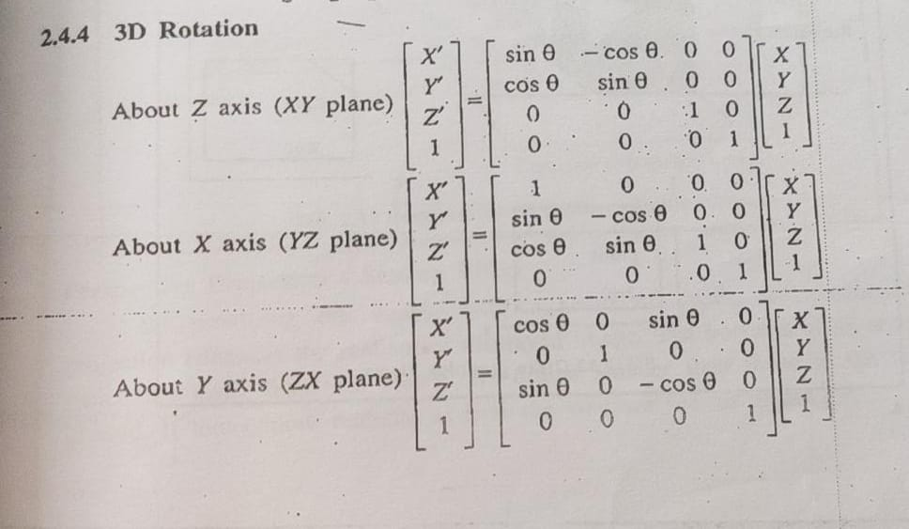

3. Represent the tetrahedron with vertices (2,2,1), (5,3,1), (3,1,3), (4,7,2) in homogenous coordinates?(3)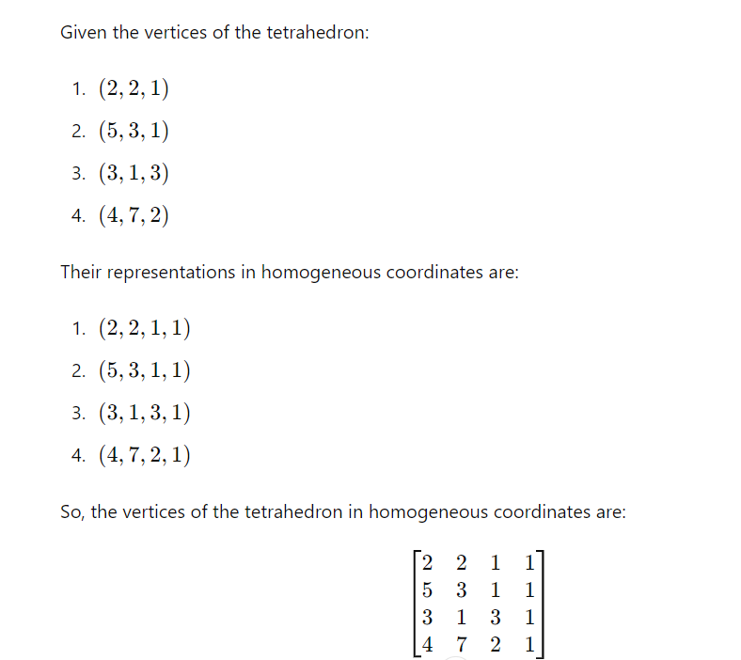

4. Explain the basic transformations in CAD?(3)

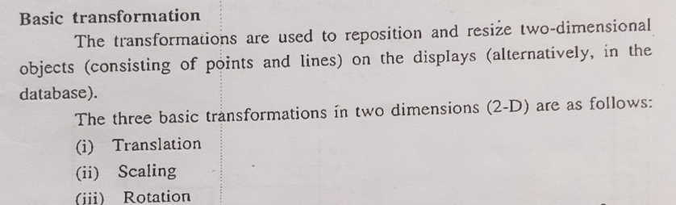

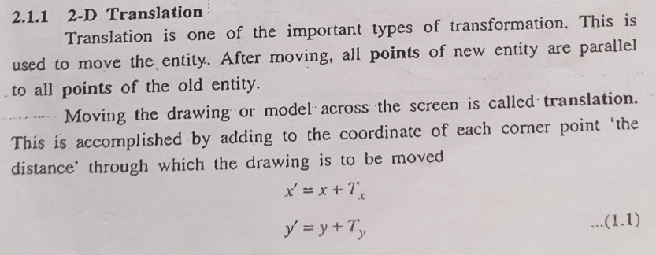

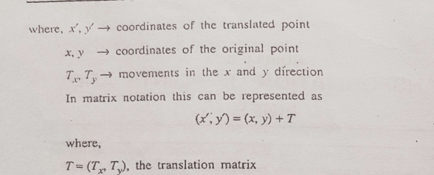

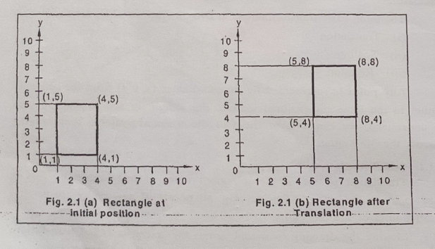

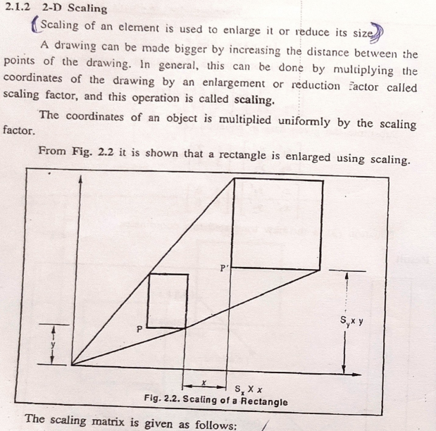

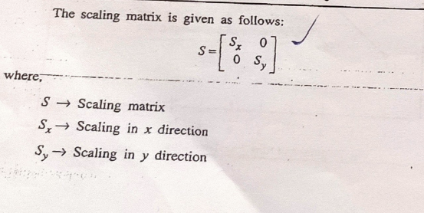

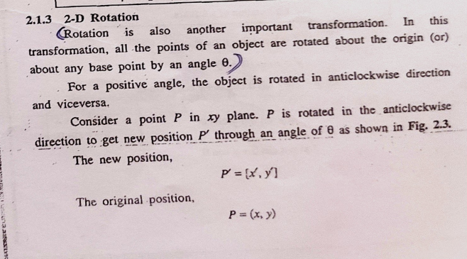

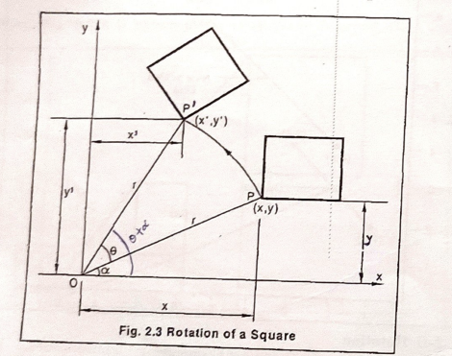

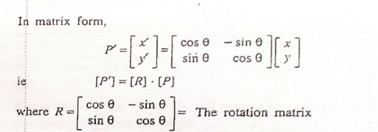

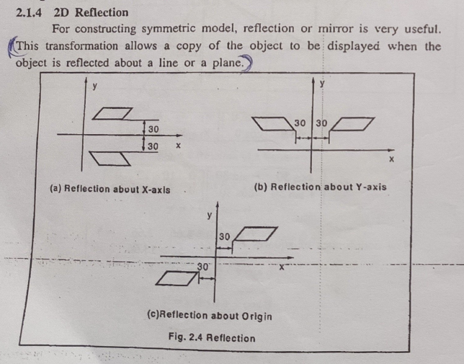

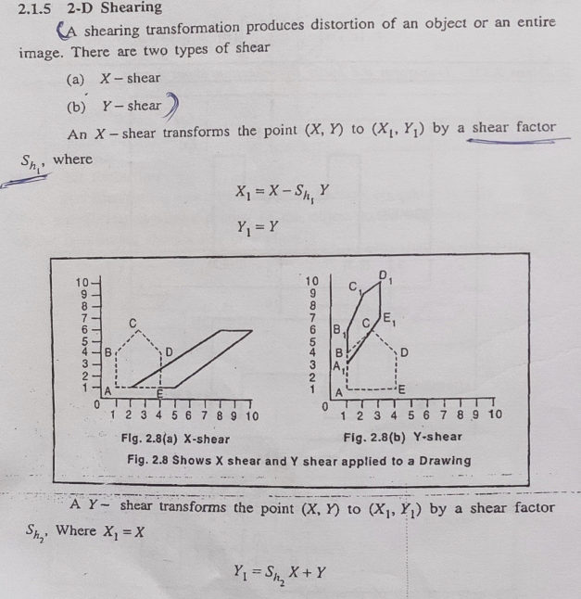

5. Write the transformation matrices for front view,Top View and Bottom View in orthographic projections?(6)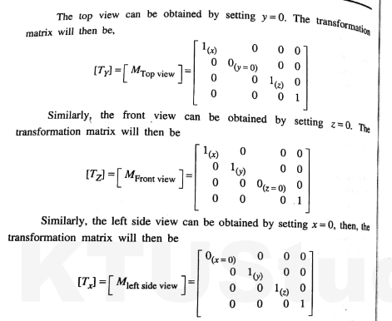

Bottom view is similar to Top view

6. Describe 2D concatenation?

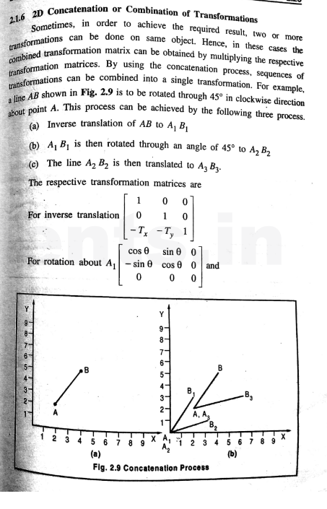

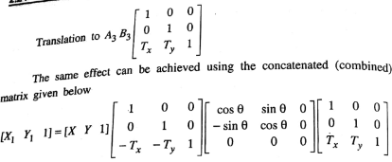

7. Consider the line of coordinates(1,1) ,(2,4).Rotate the line about the origin by 30degree.Determine the transformation of the line.(3)

8.A line of end points(5,8),(6,11) should be rotated about one of its endpoint(5,8) through 30degree anti-clockwise .Explain the transformation(6)

9.Write 2D transformation operators for shearing,scaling,reflection and rotation.(2)

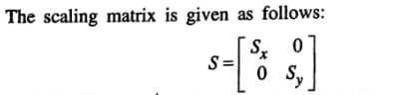

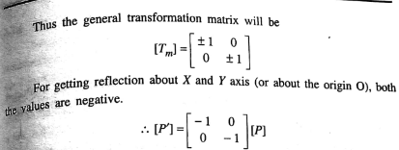

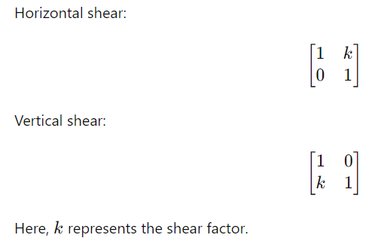

10.Formulate matrices for producing orthographic projection of a parallel pipe.(3)

ANS: – Same as qstn 5.

11.Find the coordinates of a reflected triangle having vertices (2,4),(4,3) and (3,7) about an arbitrary line represented by y=2x+2.Plot the transformed triangle.(5)

12. Write steps to rotate a triangle about its centroid which is not at origin.(2) 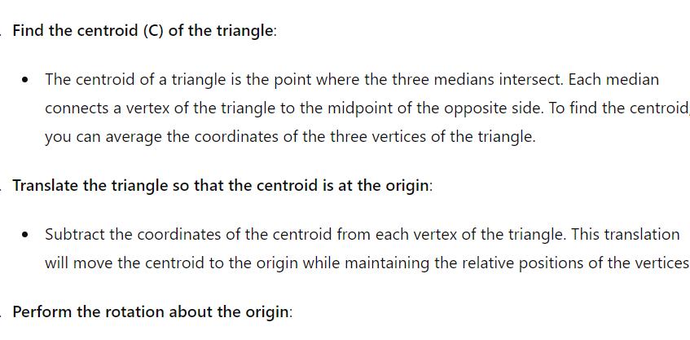

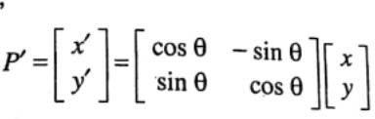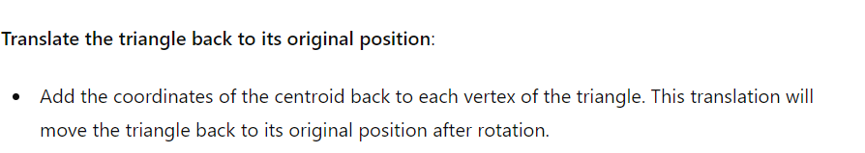

13. Derive 2D rotation transformation matrix and show that it is orthogonal.(3)

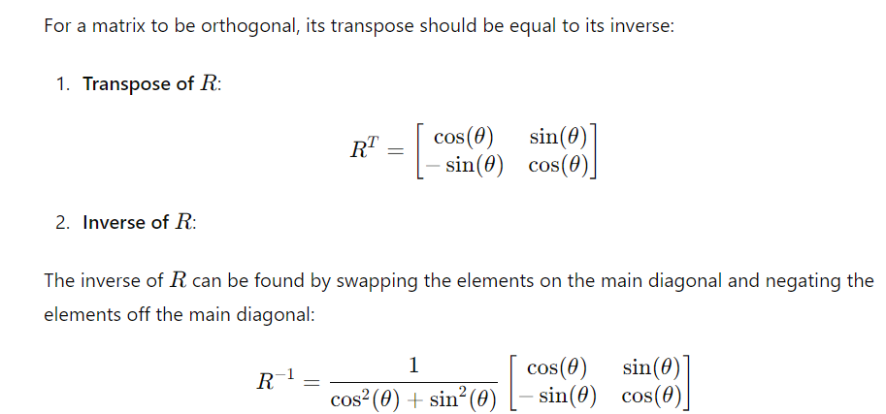

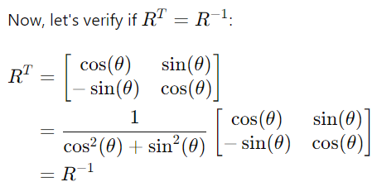

14.A square having coordinates (2,2), (5,2), (5,4) and (2,4) is to be rotated about the point(2,2) in clockwise direction at an angle 60 degree and after that it is scaled to 3 unit in X direction and 2 unit in Y direction. Find and plot the final coordinates of the geometry.(5)

15. Write general form of 2D transformation operator in a homogenous coordinate system and write the role of each sub-matrix. (3)

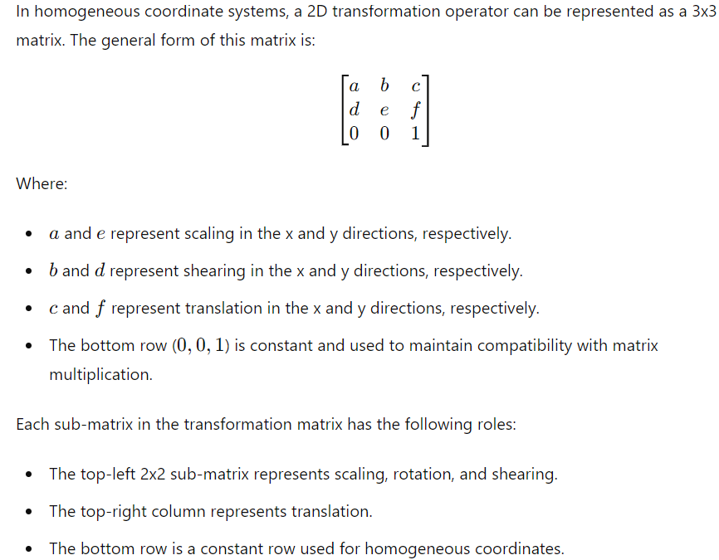

16. Illustrate the steps involved in rotating a triangle about one of its vertices which is not at origin.(5)

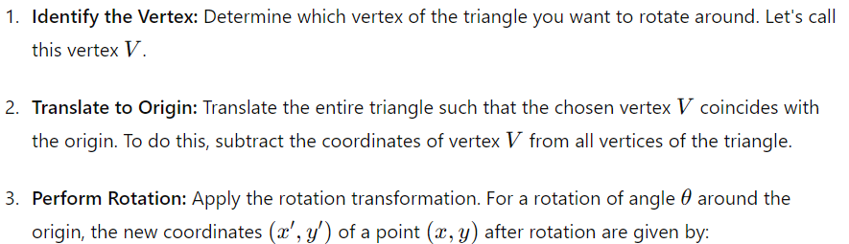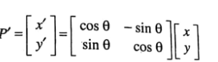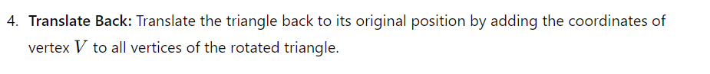

17. A triangle ABC is defined by its coordinates A(2,3), B(4,3), C(3,5) which is translated by 2 and 1.5 units along X and Y direction and then it is rotated by 60 degree. Finally it is reflected about y=x. Draw and find the final coordinates of triangle by homogenous concatenated transformations.(5) 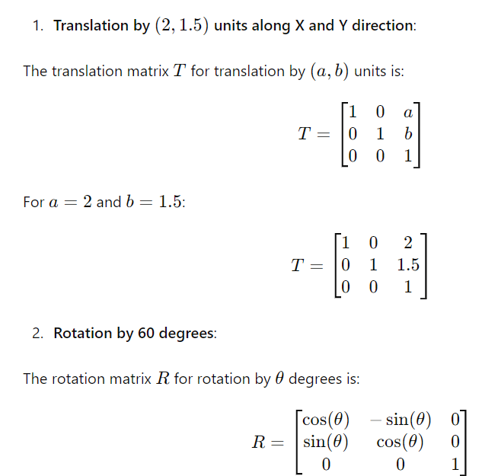

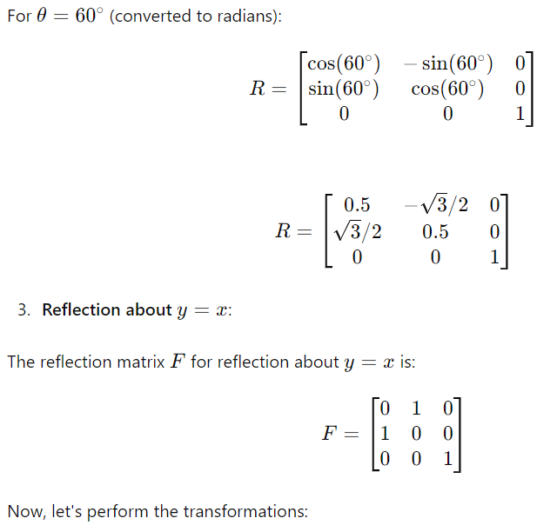

18. A rectangle ABCD is defined by its coordinates A(0,0), B(0,3), C(2,3), D(2,0) which is translated by 2 and 3 units along X and Y direction and then it is sheared about Y with shear element of 1.5 units. Finally it is scaled by 1.5units along both directions. Find and plot the final coordinates of rectangle by homogenous concatenated transformations.(5)

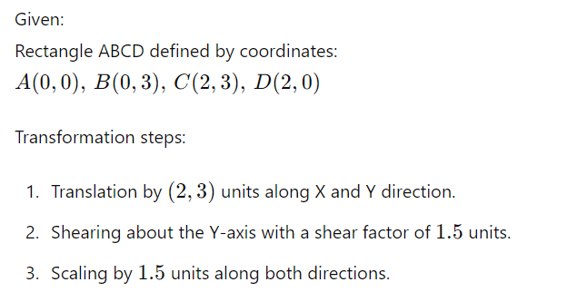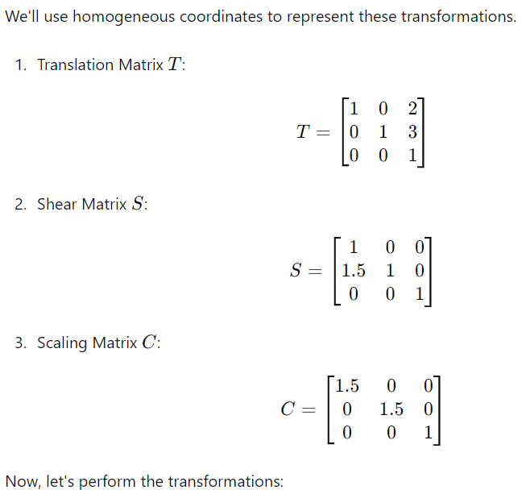

19. Rotate a triangle with end points (0,0), (6,0), (3,3) by 30degree about origin and then scale the triangle with a scaling factor of 2.sketch them……...(6)

20. Rotate a line with end points (2,3) and (3,8) by 40degree about the point (2,3)………..(5)

21.Explain the term clipping.(2)

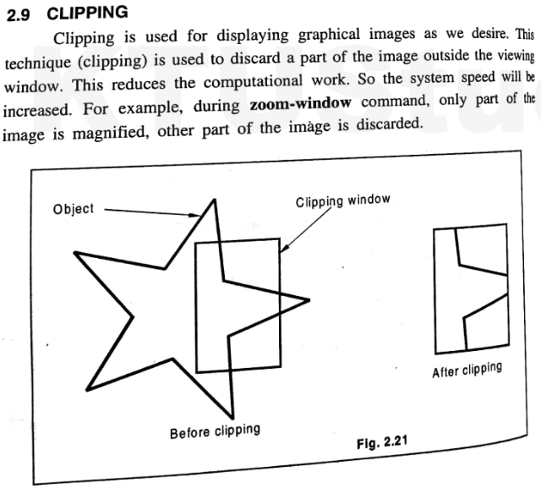

22. Write short notes on 3D scaling?(3)

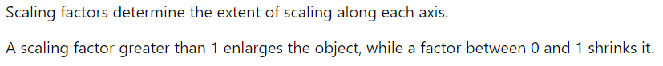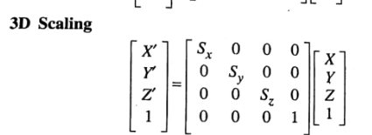

23. A line PQ is scaled by a scaling factor 3 and rotates by 45degree.End points of given line PQ is (4,5) and (7,8).Show the transformation.(6)

24. Write transformation operators for 3D reflection in XZ plane and YZ plane?(2)

25. With neat sketches illustrate the concept of developing isometric projection of a parallel pipe whose faces are initially parallel to coordinate axes and none of its points are not the origin. (5)

26. What is rigid body transformation? (2)

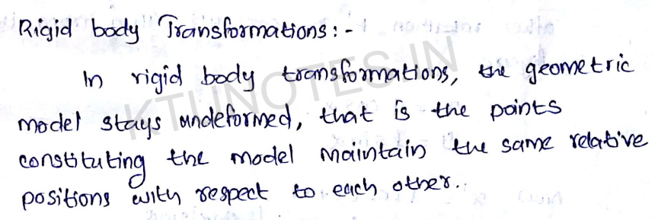

28. Two links A and B are connected by a pin joint at O2. The link A is connected to the ground by another pin joint O1. Link A rotates 90degree CCW about O1 and link B rotates 90degree CW about O2. Find the final position of point P. Use rotation transformation matrices.

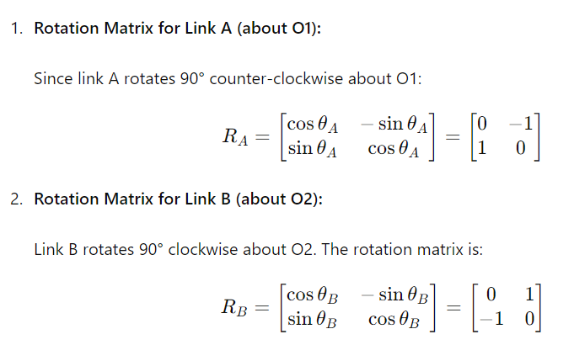

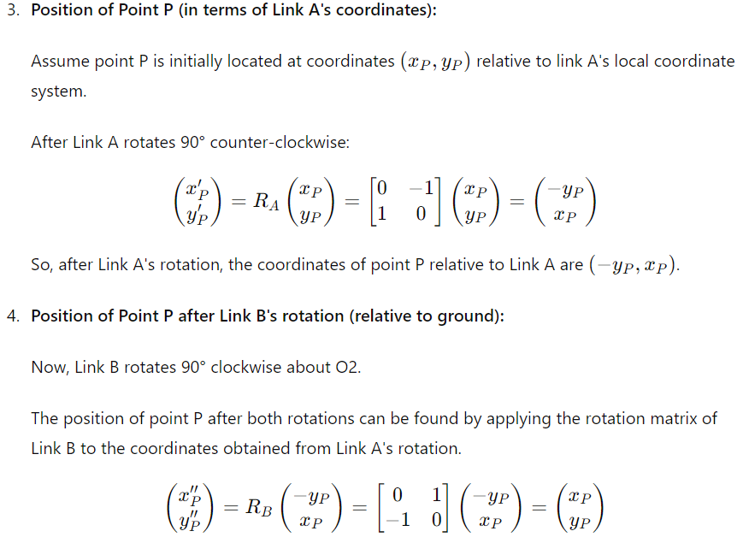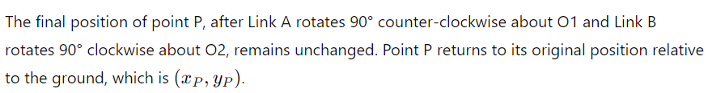

30.Describe homogenous coordinate system with its advantages. (6) 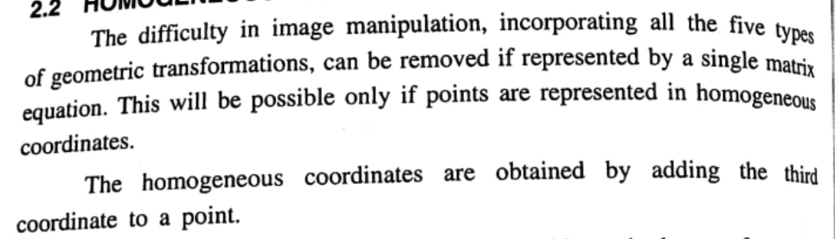

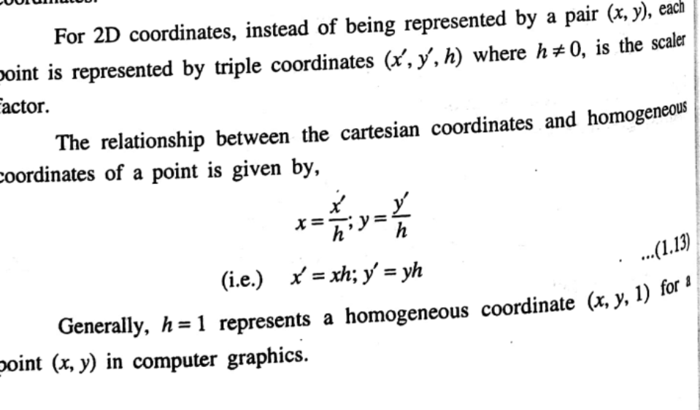

ADVANTAGES:-

1. Translation can be represented as a matrix multiplication
2. Convenient Representation of Infinite Points
3. It can improve numerical stability
4. Flexible Representation of Coordinate Systems

31. Orthographic Projections

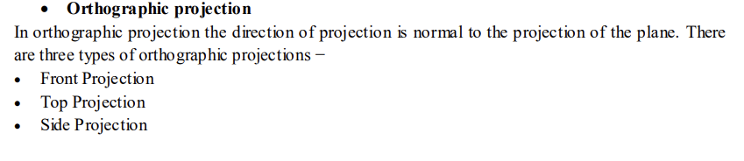

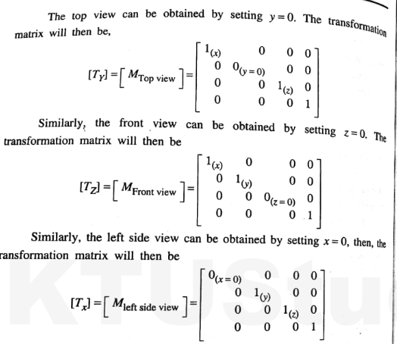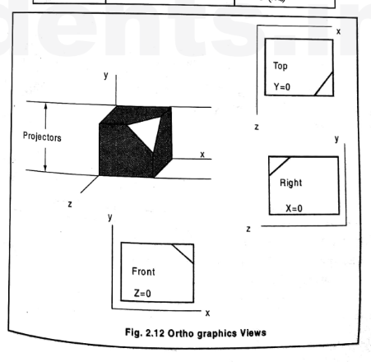32. Perspective projection

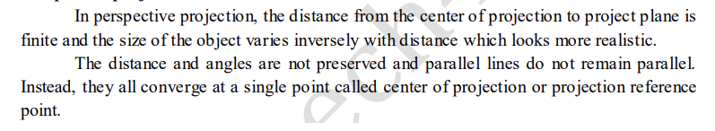

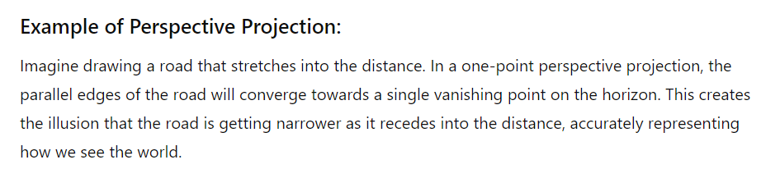

33. 3D Reconstruction

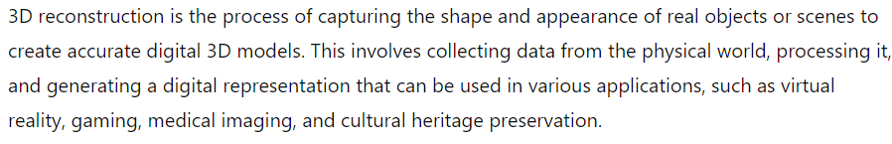

This process can be accomplished by either by passive method or active methods.

`